1. **Welcome message**
2. **Pizza Type**

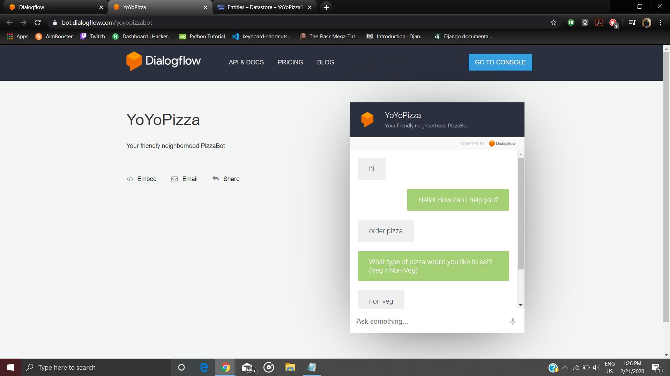

1. **Pizza Topping**
2. **Pizza Size**

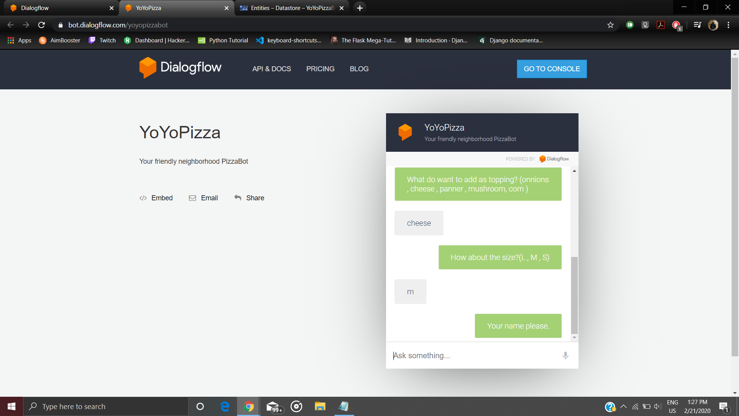

1. **Enter Name**
2. **Enter Number**

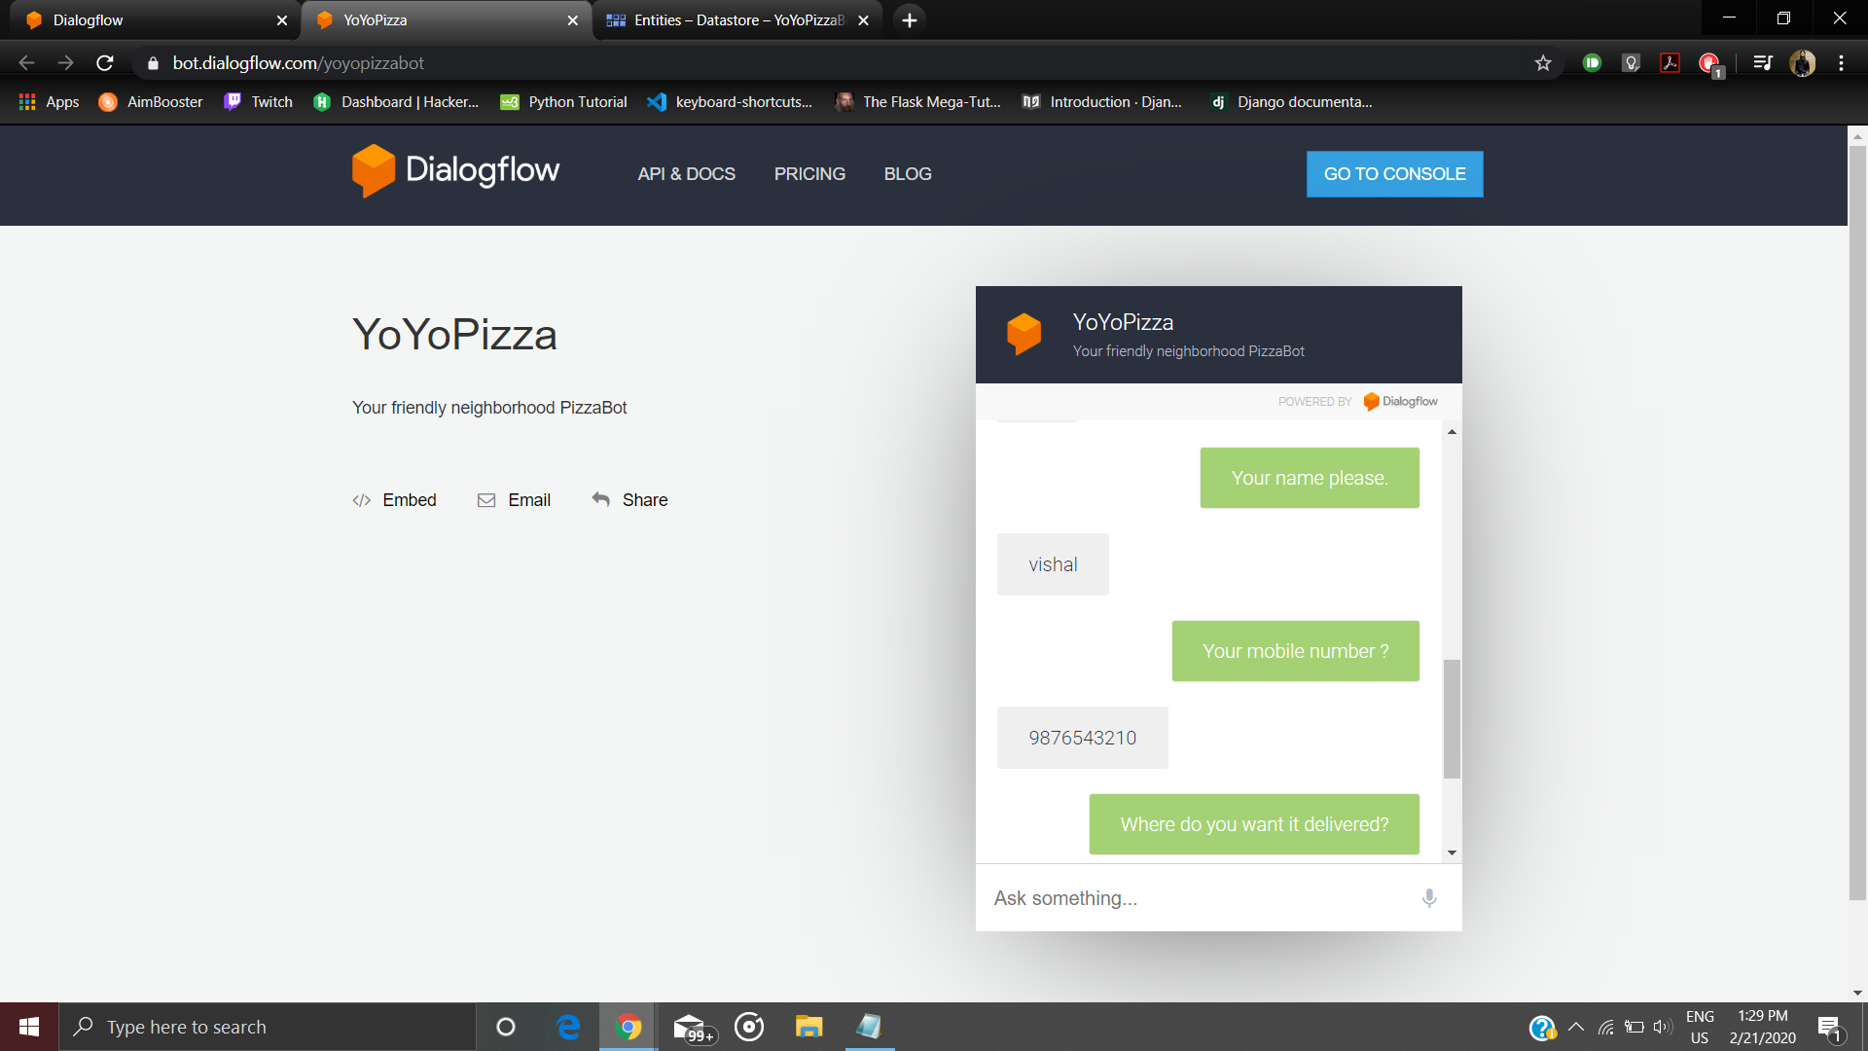

1. **Enter Address**

